Qualification details
Training Package Code and Title | ICT - Information and Communications Technology (Version 8.1)
Qualification National Code and Title | ICT50220 Diploma of information Technology (Release 2) | State code | BGJ4
Assessment Title  (as per DAP) | Assessment Task One - Part A (Individual Project)
Unit National Code & Title | ICTPRG535 Build advanced user interfaces
Unit National Code & Title | ICTPRG547 Apply advanced programming skills in another language
Unit National Code & Title | ICTICT517 Match ICT needs with the strategic direction of the organisation
Date Due | Week Two |  | Date Received |  | 10/02/2026
Student Name | Samuel Bailey
Student Declaration | I declare that the evidence submitted is my own work:  SBailey
Assessor Name
Assessment Decision | ☐ Satisfactory |  |  | ☐ Not Yet Satisfactory
Assessor Signature |  |  |  | Date
Is student eligible for reassessment (Re-sit)? | ☐No | ☐Yes |  | Re-assessment Date: |  | Week nineteen
Feedback to student
Via Blackboard (LMS) – Please check [Grade] section.

Feedback from student
Via Blackboard (LMS) – Please use [Comment] section during submission.

Student signature |  | Date

Assessment Instructions
TO THE ASSESSOR
Type of Assessment | Individual Project
Duration of the assessment | 2 class sessions (Weeks 1 - 2)
Location of assessment | Classroom
Conditions | Assessor to ensure that the noise levels, natural interactions and time variances are maintained as it would be in the Software Development industry.  Learners are required to complete the required tasks in class and submit the required documentation electronically via Blackboard
Elements and Criteria | As detailed in the assessment plan  You are required to make sure that all students meet the elements, performance criteria and oral communication items as outlined in the provided solution
TO THE STUDENT
Purpose of Assessment | You are required to show you can:  ICTPRG5335 Build advanced user interfaces  - Plan and design a UI solution according to organisational requirements,  - Apply interactions designs and implement validation requirements against the design plan,  - Create and display the UI with graphics according to UI requirements.  ICTPRG547 Apply advanced programming skills in another language  - Code advanced data structures using hashing, sorting and searching algorithms,  - Apply third party libraries and communication technologies for data exchange,  - Test and evaluate the code to resolve logical and syntactical designs flaws,  - Create and document the application according to technical specifications.  ICTICT517 Match ICT needs with the strategic direction of the organisation  - Interpret, analysis and report the strategic organisational plan  - Propose and document changes for the implementation of a ICT system  - Provide action plan and schedule  The student must demonstrate the ability to complete the tasks outlined in this assessment and is expected to use systematic analytical processes and effect time management to meet the goals/deadlines outlined in the DAP.

Allowable Materials | Blackboard Topics, SDLC, Weekly readings (PDF), Example programs and Independent Outside of Class Activities
Required Resources | Web links and example code can be downloaded from the Blackboard portal.  PC with Notepad++, Visual Studio, GitHub, MSOffice.  Internet Access to GitHub and www.citems.com.au/
Reasonable Adjustment | In some circumstances, adjustments to assessments may be made for you. If you require support for literacy and numeracy issues; support for hearing, sight or mobility issues; change to assessment times/venues; use of special or adaptive technology; considerations relating to age, gender and cultural beliefs; format of assessment materials; or presence of a scribe you need to inform your lecturer.
Assessment Submission | All questions and programming activities must be attempted. All written answers must be submitted in this assessment document in the appropriate space.  Use of research tools and peers in formulating answers are acceptable – but work submitted must be your own work.  Final project documentation is to be uploaded to the appropriate area in the Blackboard course created for this unit.  If you are marked as NYS (Not Yet Satisfactory) on your first attempt, you will be provided with another opportunity to re-attempt the assessment.
Portfolio Description | A project of web coding tasks and written questions which should be completed in class and finished in the students’ own time on a weekly basis as per the Delivery and Assessment schedule.  Part A  Question 1 – Design Specification  Question 2 – Version Control  Question 3 – Design Approval  Part B  Question 4 – Application Development  Question 5 – Debug and Testing  Question 6 – Evaluation  Question 7 – Assessment, Feedback and Signoff

Scenario
You are employed as the Senior Programmer with CITE Managed Services and have been assigned the Satellite Data Processing Project for an organisation called Malin Space Science Systems (MSSS). This project will require the planning, development, testing and reporting of an application that will sort and search complex data sets recorded during satellite operations. The senior scientists at Malin would like two sorting and two searching algorithms so they can compare the processing of raw data as it is collected. This application will utilise two advanced sorting algorithms and two binary searching techniques. The details and criteria are provided in the following paragraphs.

Background Information
Marlin Space Science Systems operate a satellite with a Sun-synchronous orbit, which means they can record data from the same spot at the same local time each day. The advantage for scientists means they can compare data from a fixed location over a long period of time to detect changes. The data is collected as raw numbers from two sensors on the satellite as it passes over the receiving station. This stream of numbers forms a Normal Distribution and is then transmitted and saved onto a server for further examination. The processing occurs when each data stream is read into the application using a mathematical formula embedded in a Dynamic Link Library called Galileo. Currently the scientists use a 32bit command line application which is executed from a console, this old software is not able to run successfully on new multi-platform hardware. There has been a series of recordings that are outside the expected range of normal readings and the scientists at Malin require a replacement application which could provide accurate information. Therefore, the organisation has requested a .NET Multi-platform App UI that is compatible with contemporary hardware. The analysis team have consulted with Marlin and provided an image of the old interface layout for the display of satellite information with the required features.
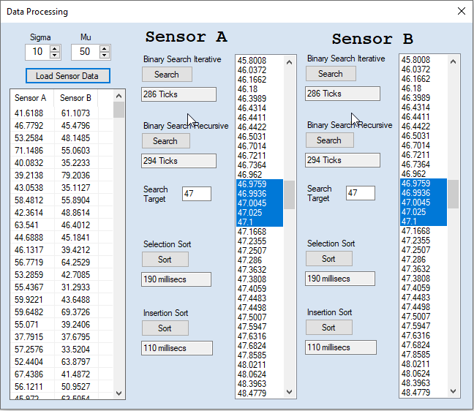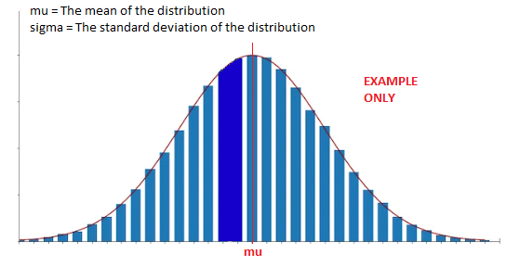
Ref: https://en.wikipedia.org/wiki/Sun-synchronous_orbit
Ref: https://www.esa.int/ESA_Multimedia/Images/2020/03/Polar_and_Sun-synchronous_orbit

Application Requirements
The Marlin scientists require a .NET WPF App (refer Appendix) using a C# code base to process the data using the Galileo DLL and two LinkedList’s; one for each satellite sensor. The data from each sensor must be read into a simple LinkedList of type “double” and then sorted using a Selection and Insertion sort algorithm. Next, the scientist will enter an integer value into a search textbox and select a Recursive or Iterative binary search algorithm. Finally, for each of the four algorithms the processing time must be measured and displayed.
The Marlin scientists would like buttons for each action and several display options to examine the raw data and processed information. The application must have a single form that shows all the information from the two sensors. The following features are mandatory:
- A List Box to display the data from each Sensor.
- A List View with two columns to display the data from both sensors (Sensor A and Sensor B).
- A numeric input to control the standard deviation (Sigma) and mean (Mu) of the data.
- A button to load data into the two LinkedLists and then display these LinkedLists in a List View.
- A series of buttons to process the sort and search functions.
- Textbox display for the processing times for each sort and search.
You should consult with the CITE representative (your Lecturer) if you are unsure about any of the problems or questions in this assessment. Your primary research should focus on the resources on the Blackboard LMS and CITE web site, additional information can be collected from the Internet, ensure all sources are referenced in your submission. Ensure your development follows an Agile methodology that is recorded and maintained using your GitHub account. You must demonstrate your working applications before uploading to Blackboard, your Lecturer (Assessor) will sign off to ensure all the criteria are satisfied.

Question 1 Design Specification
Provide a suitable description/explanation for each client requirement, and then complete the UI design specification which outlines all the user interactions that occur when buttons and related components are clicked or selected. Complete the following Design Specification template to answer this question.
Design Specification
Developer Name | Samuel Bailey |  | Date | 3/02/2025
.Net Version | 8.0
Client Technical Requirements
Requirements |  | Description
- .NET WPF Application |  | It must be a WPF Application as it has in built features to add a GUI.
- Use of Galileo DLL |  | The application should use the Galileo DLL provided.
- Two LinkedLists for Sensor Data Storage |  | The sensor data will be stored within Two Linked Lists, one for Set A and another for Set B.
- Sorting Algorithms |  | This application requires two advanced sorting algorithms and methods to compare the two.  These algorithms will be Selection Sort and Insertion Sort.
- Searching Algorithms |  | This application requires two binary searching algorithms and methods to compare the two.  These algorithms will be Binary Recursive and Binary Iterative
- GitHub Source Control |  | This application will be uploaded to GitHub to have proper versioning and source control.
UI Design Specification
What are the User Interactions when a form component is clicked or select?
UI Action |  | Description
Sigma and Mu Input |  | These are the inputs that are used by Galileo DLL to generate the mock datasets. Setting Sigma as the mean and Mu as the standard deviation.
Load Sensor Data Button Click |  | When the inputs are filled, the Load Data button will generate a dataset from the sigma and mu. These datasets will fill the two LinkedLists in the back end and then fill the List Boxes and the joint List View in the front end.  If the inputs are not filled, it will display and error message.
Search Radio Selection |  | This will determine which of the two Search Algorithms will be used. The two radio buttons will be mutually exclusive, meaning only one can be selected. If a radio button is clicked, the opposing one will be unselected and vice versa.
Search Button Click |  | Firstly, it will check that there is a valid integer within the Search Input and display an error message if not.  Then, depending on the radio button selected, it will search for every number that holds that search match within the appropriate digits.  The time it takes to complete this search algorithm will be recorded and then written to an Analytics List View.
Sort Radio Selection |  | This will determine which of the two Sort Algorithms will be used. The two radio buttons will be mutually exclusive, meaning only one can be selected. If a radio button is clicked, the opposing one will be unselected and vice versa.
Sort Button Click |  | Depending on the radio button, the Linked List will be sorted with the chosen algorithm, in ascending order to allow for binary search.  The time it takes to complete this search algorithm will be recorded and then written to an Analytics List View.

Question 2 Version Control
Malin Space Science Systems would like you to use GitHub as the primary source control, setup an appropriate structure in your GitHub account to manage the Satellite Data Processing Project development. Add a project to your repository which reflects the basic Agile development process you intend to pursue. Complete the following GitHub Version Control template to answer this question.
GitHub Version Control
Repository Name: | Marlin-Satellite-Sensor-System
URL | https://github.com/SamB-TAFE/Marlin-Satellite-Sensor_System | Date | 10/02/2026
Screen Shot(s) | Repo  Project  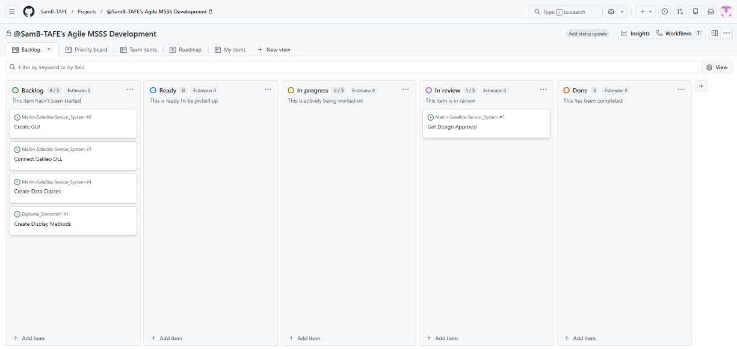

Question 3 Design Approval
Once you have complete questions 1 & 2 email your document to your lecturer to be reviewed by the Lecturer/Assessor for approval and feedback before submission. Once your Design has been approved your lecturer will send you a copy of the Galileo DLL. Ensure you stipulate the version of .Net you will be using, this may affect the performance of your application.
- Question 1 Design Specification
- Question 2 Version Control
Design Approval (Lecturer/Assessor use only)
Approver Name | Title | Signature | Date | Approved?
Blake Williams | Lecturer | B_williams | 10/02/2026 | YES
Lecturer Feedback
Please provide a screenshot of your repo. Please list your searching and sorting algorithms.
Check all the above documentation has been completed and is ready for inspection. Contact your Lecturer (Assessor) and arrange to submit your document(s), use the following Checklist to ensure you have completed all the assessment criteria.
Checklist |  | Completed
Questions |  | YES NO
Q1 | Design Specification: All fields of the Design Specification are filled in. | ☒ | ☐
Q2 | Version Control: All fields of the template are filled in. | ☒ | ☐
Q3 | Design Approval has been submitted to the Lecturer | ☒ | ☐
Note: All documentation must use the supplied templates/forms.
Submit the zipped solution folder with relevant documents to Blackboard.
End of Assessment Task One – Part A

